2018 REGISTRATION FORM  COMPANY NAME: | 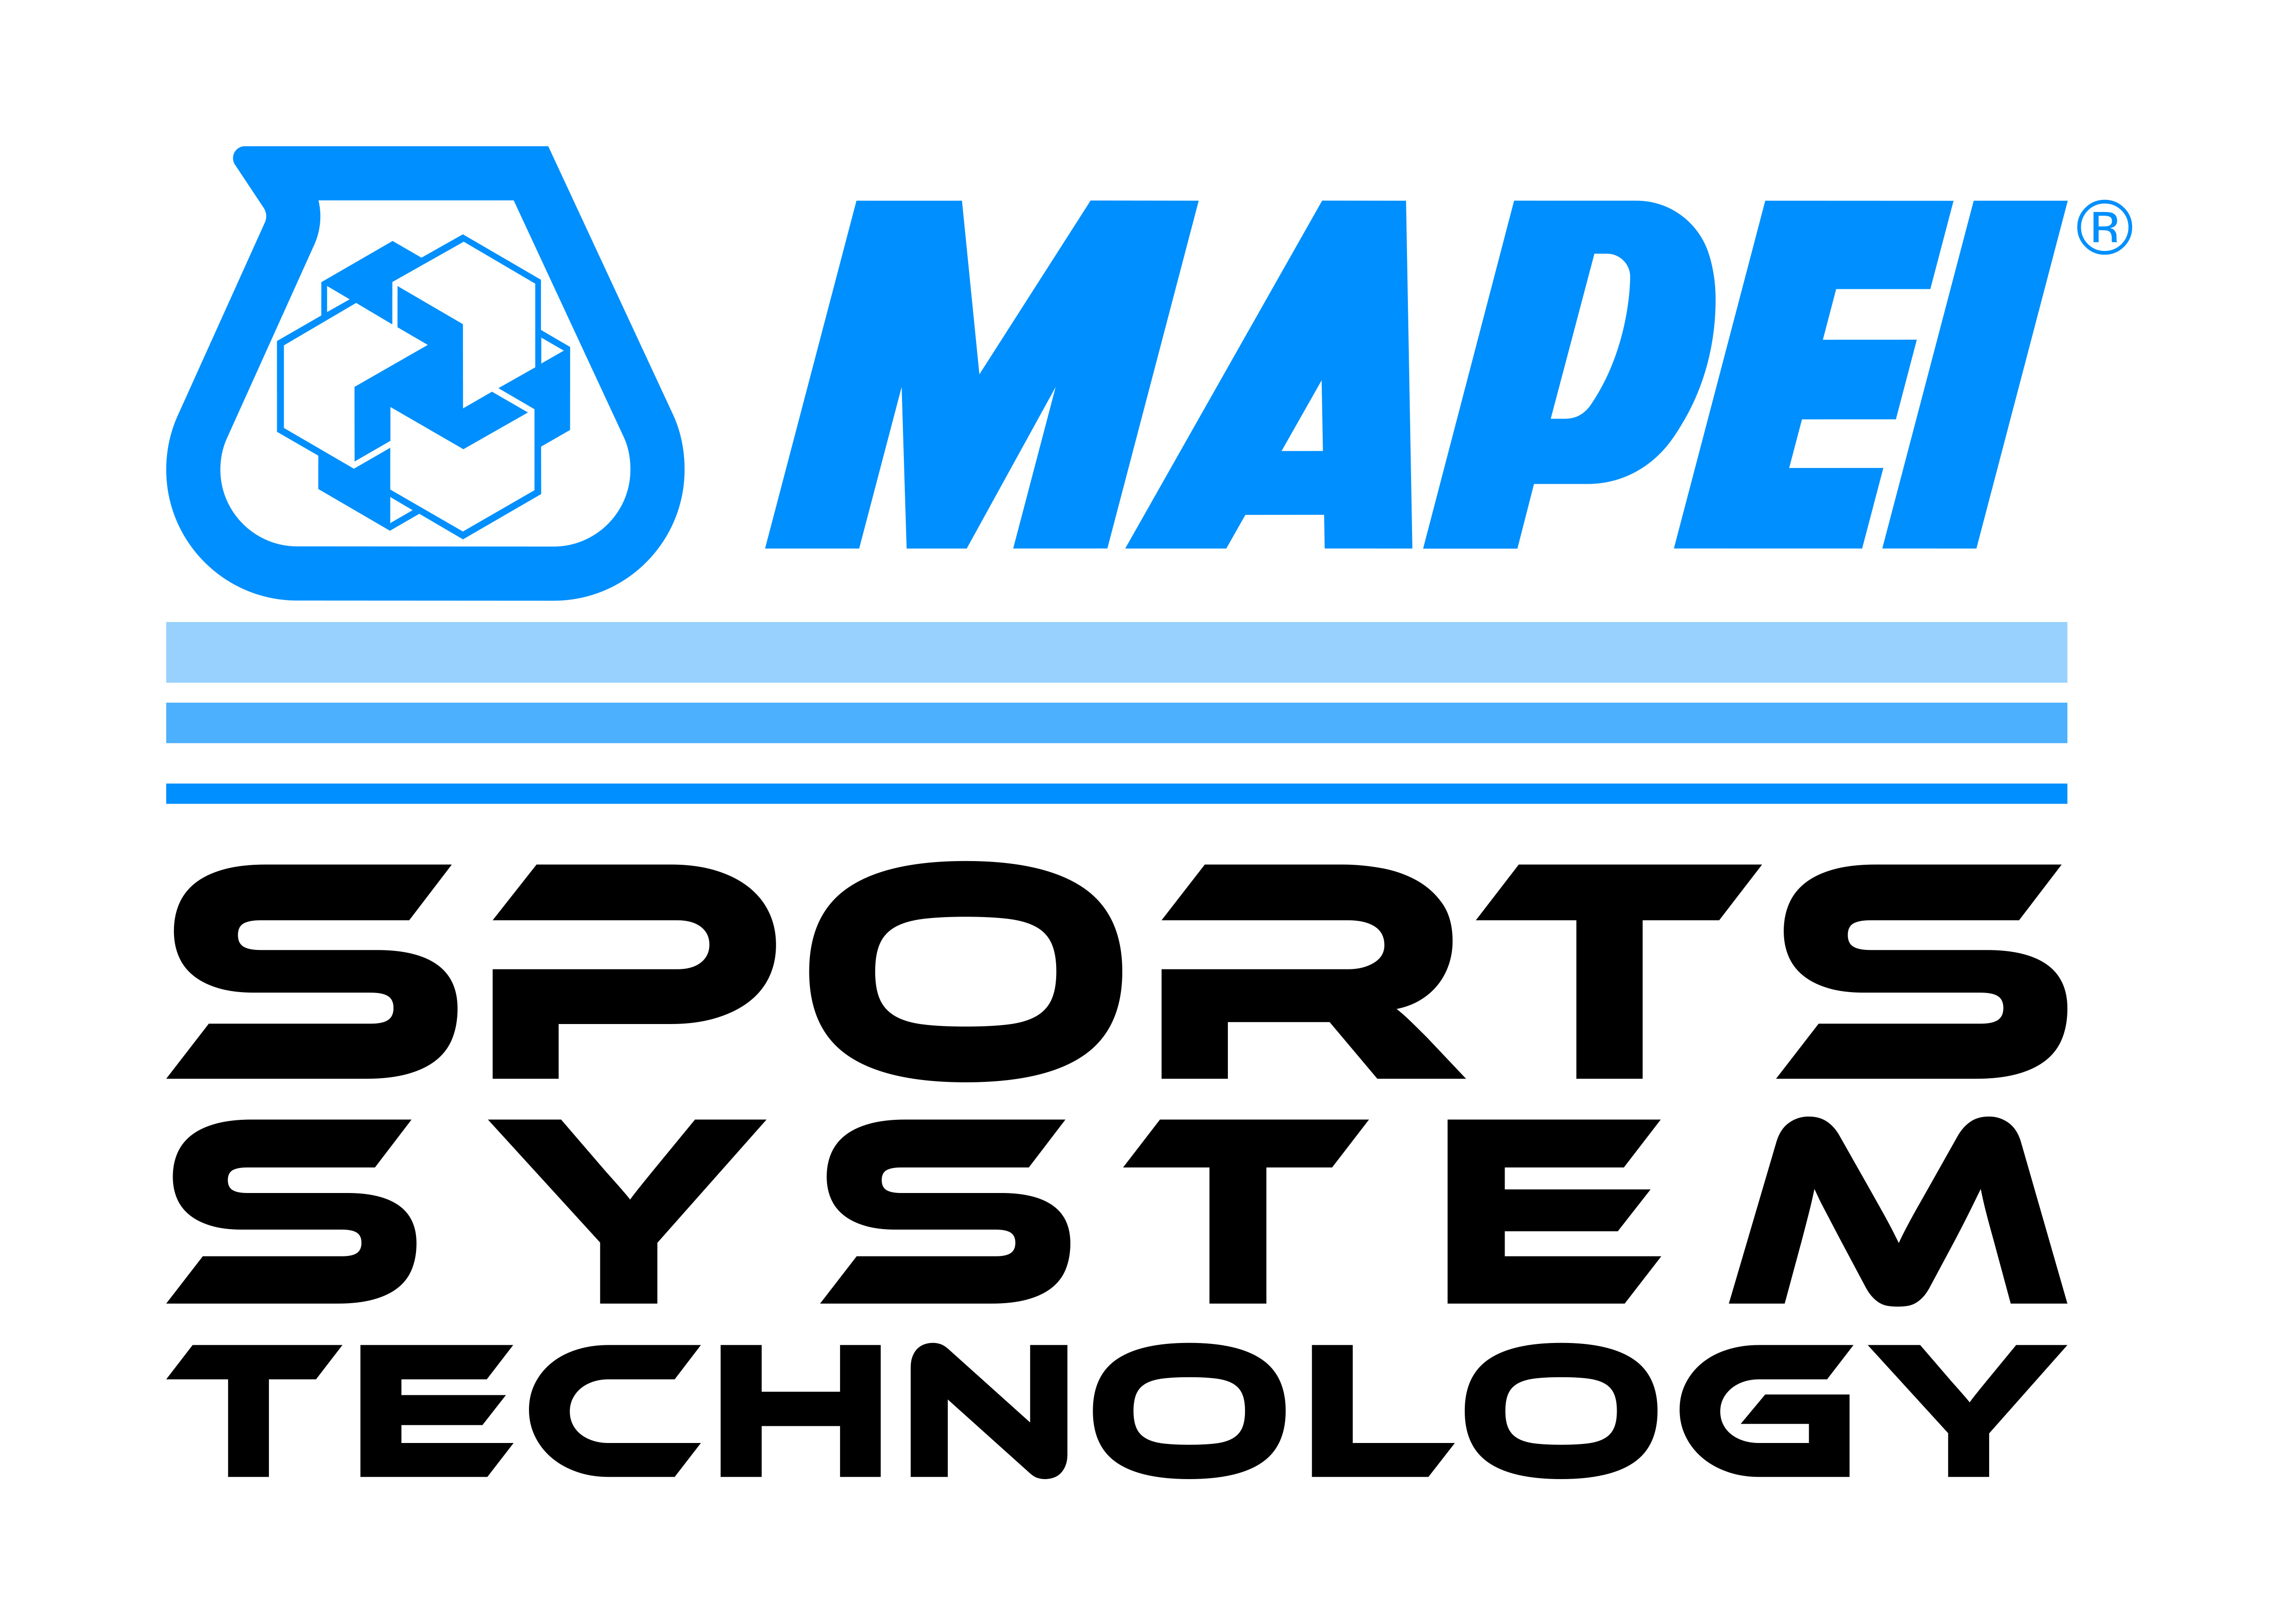  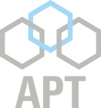  GOLD SPONSOR SILVER SPONSOR
Thursday 30 August 2018 | Please complete where applicable
SOCIAL GOLF: 10.40 am  Coolangatta & Tweed Heads Golf Course  Soorley Street, Tweed Heads South NSW  $59 per player, includes one cart per two players.  $30 club hire – please indicate if required and note if left-handed clubs required.  Please indicate if handicap rating is Golf Australia (GA),  Social (S) or Unrated (U).  Fees are payable direct to Club on day of event. | Player 1:  Handicap:  Club Hire: | Player 2:  Handicap:  Club Hire:
 | Player 3:  Handicap:  Club Hire: | Player 4:  Handicap:  Club Hire:
ANNUAL GENERAL MEETING: 5 pm  Mantra On Salt Beach Conference Room ‘Plantation 1’  Includes the President’s Report, Financial Reports and Election of Board Members for next 12 months | Name/s of company representatives who will be attending the SAPIA AGM:
WELCOME FUNCTION: 7 pm  Mantra On Salt Beach Pool Deck  2 hours of Canapes and 3 hours of Beverages  No charge – function sponsored by APT ASIA PACIFIC | Name/s of SAPIA members and guests who will be attending the Welcome Function:
Friday 31 August 2018
NATIONAL CONFERENCE: 9 am – 5 pm  Mantra On Salt Beach Conference Rooms ‘Plantation 2 and 3’  Delegate Fee Categories:  $470 First delegate per company  (includes attendance at Annual Dinner)  $420 Additional delegates from same company  (includes attendance at Annual Dinner)  $320 Conference Delegate only  (not attending Annual Dinner)  $150 Annual Dinner guest only  (not attending Conference) | Names of conference delegates and dinner guests who will be attending the SAPIA National Conference & Annual Dinner:
 | Name |  | Delegate Category
MEMBERS EXPO: 9 am – 5 pm  A small number of expo spaces or tables are available in the Exhibition Hall ‘Plantation 1’, at a cost of $250 each.  Only 13 tables are available, so please book early. | Please email office@sapia.org.au if you are interested in exhibiting during the Conference.
Do not pay now – an invoice will be raised.

